VFW Department of Maine Shirts
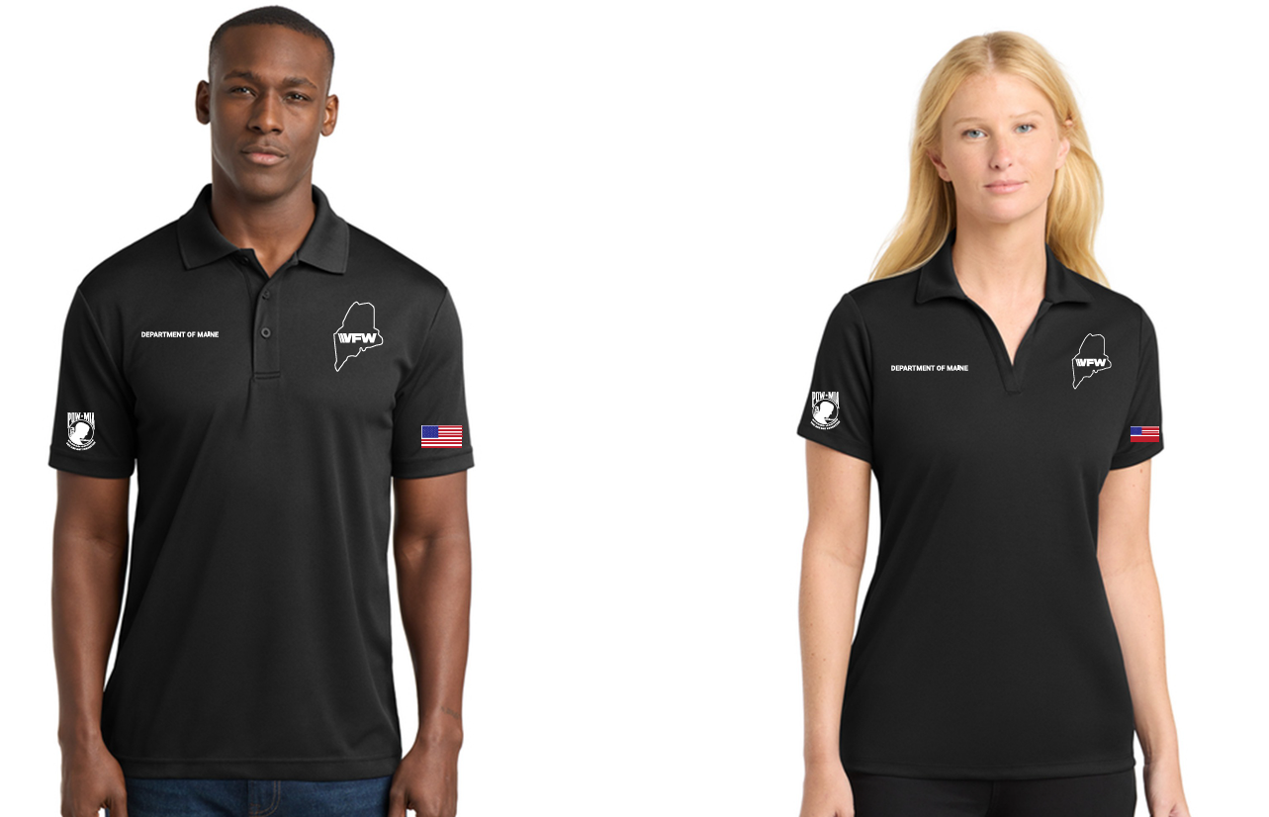
Order Form
Cost per size Sizes S-XL- $44 2XL or Larger $48 (Includes shipping)

Name: _____________________________________________________

Size: _____________ Men: ___________ Women: ___________

If different size, type or writing on right side please use separate ordering form.
Please write neatly to ensure proper printing

Right Side:
Line 1 _________________________________________________________________
Line 2__________________________________________________________________
Line 3__________________________________________________________________
Payment: Cash: __________ Check: _____________ Venmo: __________

Your contact number for any question on the shirt_________________________________

Cash and Checks mailed to Steven SanPedro 251 Gray Road, Windham, ME 04026

Checks made out to Steven SanPedro

Venmo to @stevesanpedro

Forms mailed to Steven SanPedro 251 Gray Rd, Windham, ME 04026 or emailed to sanpedro105@roadrunner.com

